# Conversation with Steve 13 July 2016

Using Join.me to look at the application.

Most on the screen is memory based. Save puts to the database.

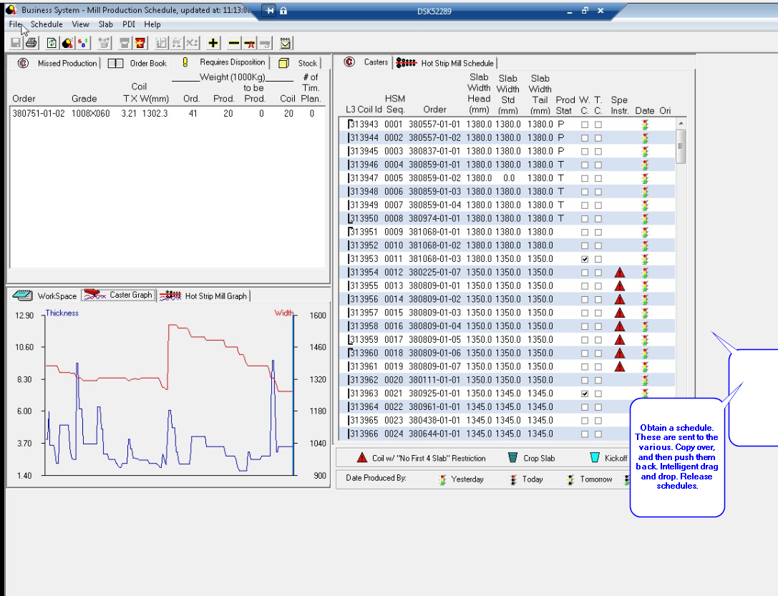

Heat List. Look at the list, check alternate grades

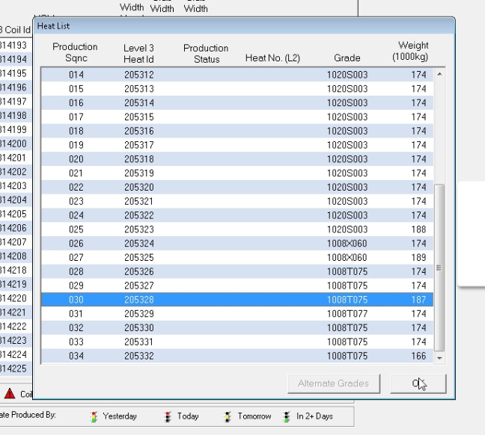

Can transmit the PDI.

Not just a matter of displaying on a terminal.

Deprecated functions.

Look at the menu below. Some functions are deprecated and therefore not used.

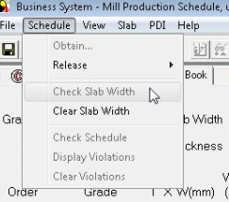

# Getting the Software to Build

Used the VM Win10-VS2012

Installed Visual Studio 2003 Pro from MSDN Account.

Only installed C++ portion.

Unzipped SPC.ZIP, and placed it under C:\NSBS

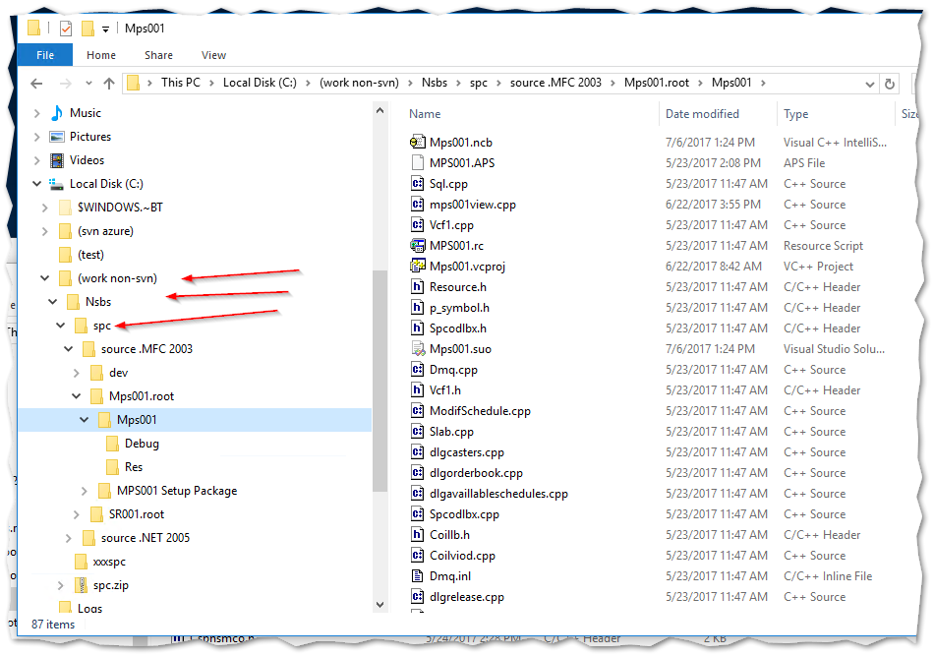

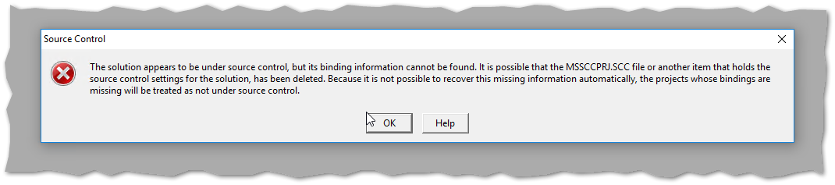

Ignored the SourceSafe errors.

Could not build because of a missing BEA Message Q file: p_entry.h

Found the file in my archives (WDC2004) and was able to compile.

Could not link because of missing references, so built a stub WinForms C++ applications and used the references that were found there:

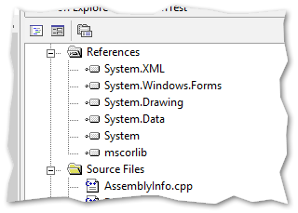

The link was then able to complete, but there were two missing DLLs at runtime:

Libct.dll and Libcs.dll.

These are apparently used by the database client (Sybase).

The search locations in the project > Settings are:

* ..\..\dev\LIBSPC.root\LIBSPC
* ..\..\dev\LIBSPC.root\LIBSPC\SybaseDebug
* ..\..\..\BEA MeassageQ\lib"
* ..\..\dev\Spcres.root\Spcres\Debug
* ..\..\dev\Pps_lib.root\Pps_lib\debug
* ..\..\dev\CheckRes.root\CheckRes\Debug

Note the annoying misspelling of MeasageQ (should be MessageQ)

Needed the Sybase files libct.dll and libcs.dll.

Steve sent the Software_Packages.zip file, which contained several installation kits, including the Sybase kits.

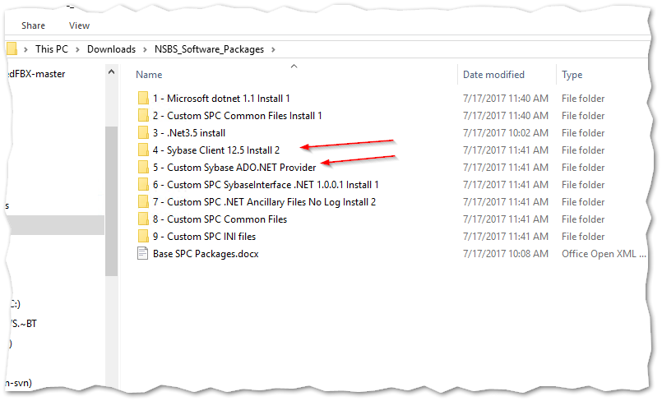

Under c:\sysbase\OCS012_S\dll\debug and nondebug live the libc*.dll files.

A reboot is necessary to pick up the environment variables:

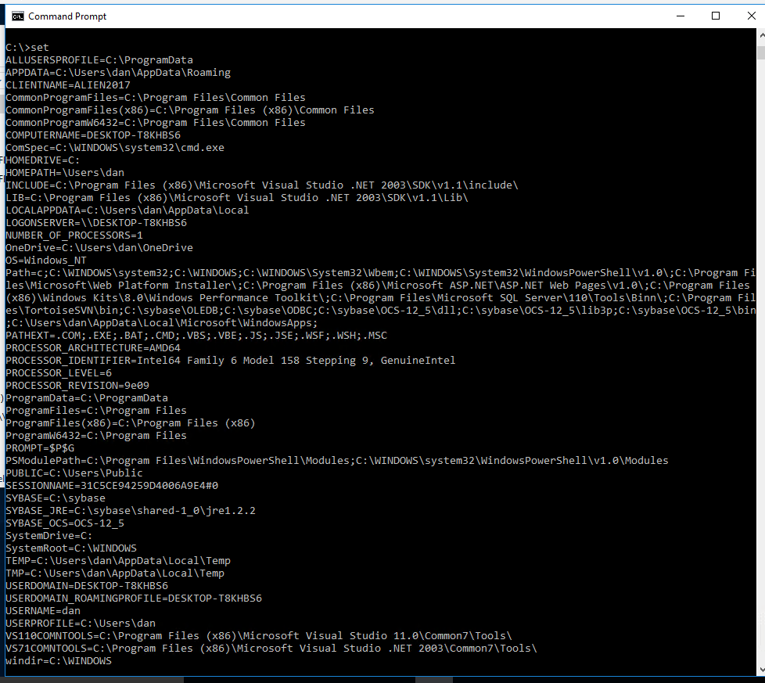

After the reboot, the VS2003 program compiles and runs, and gives this prompt:

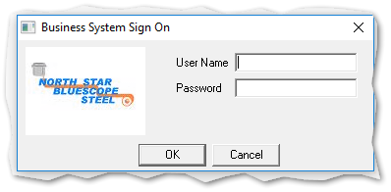

The last package installs the INI files:

Here is the readme for the file: Readme Custom SPC INI files Rev 3.txt:

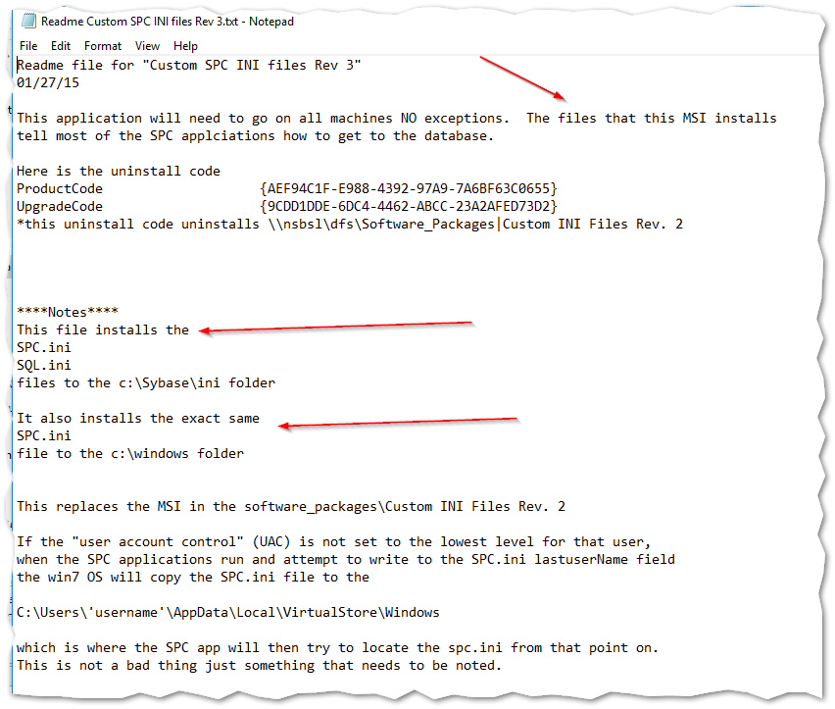

## MSI Installation Dialog

And here is part of the installation dialogs:

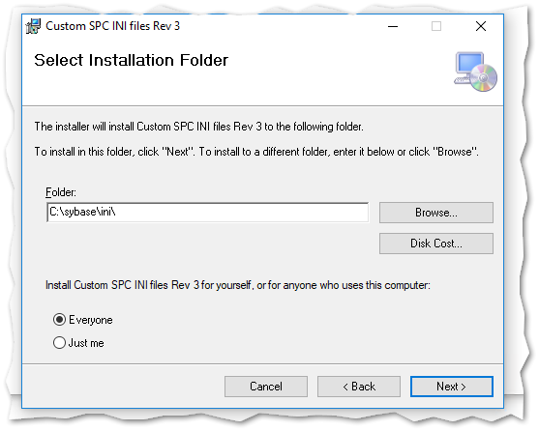

# VPN Access

Needed Cisco AnyConnect, which lived at https:\\vpn.nsbsl.com

The automatic installation doesn’t work, so do the Cisco download, and then install it (which includes a Java program.

Then launch:

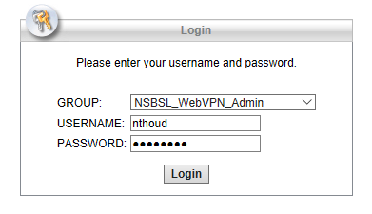

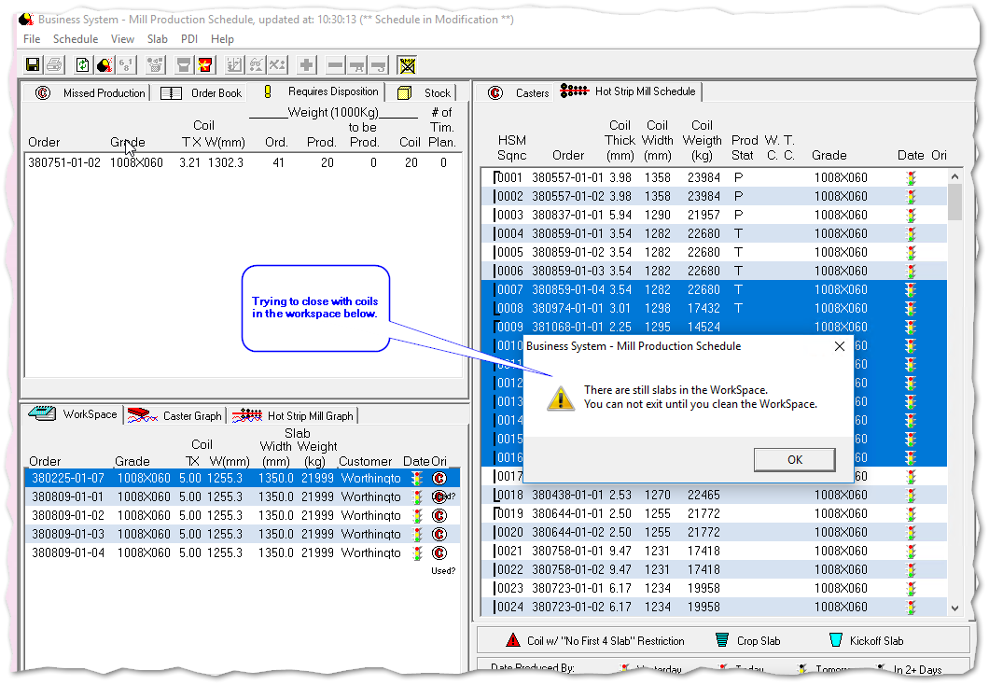

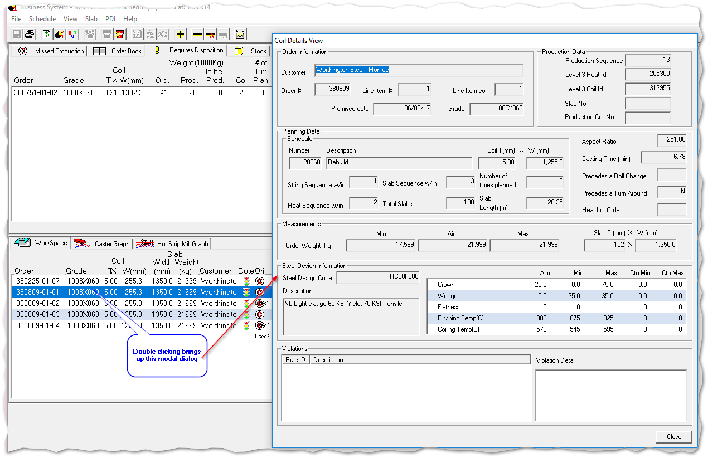

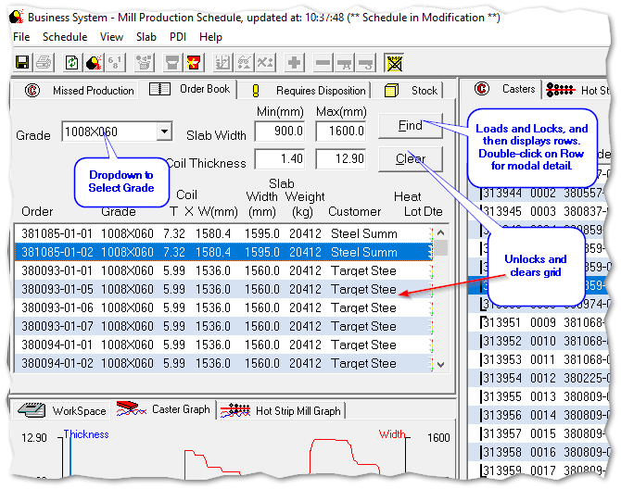

# Messaging

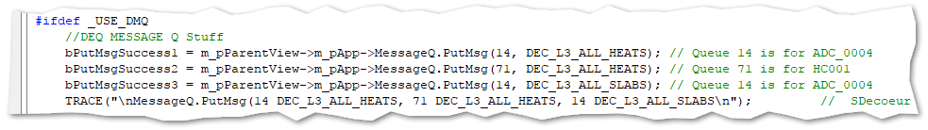

# ScreenShots

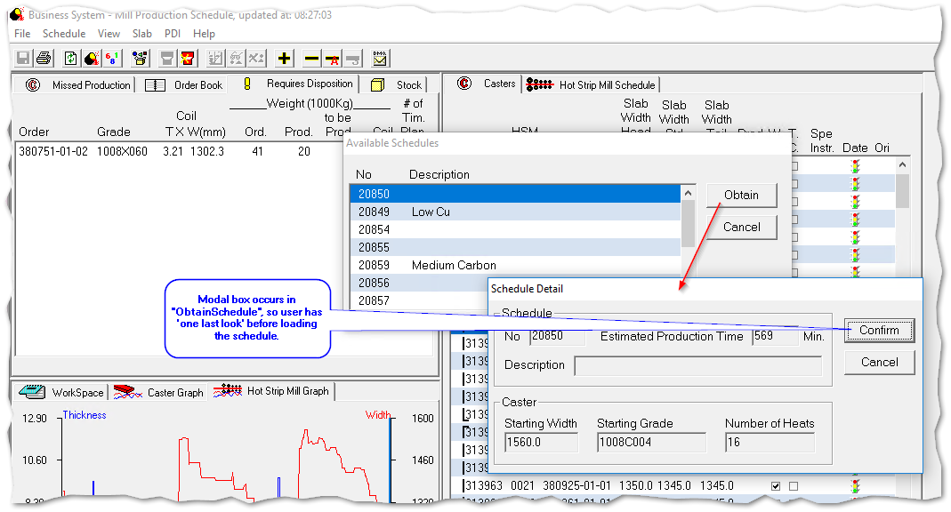

Find Coils

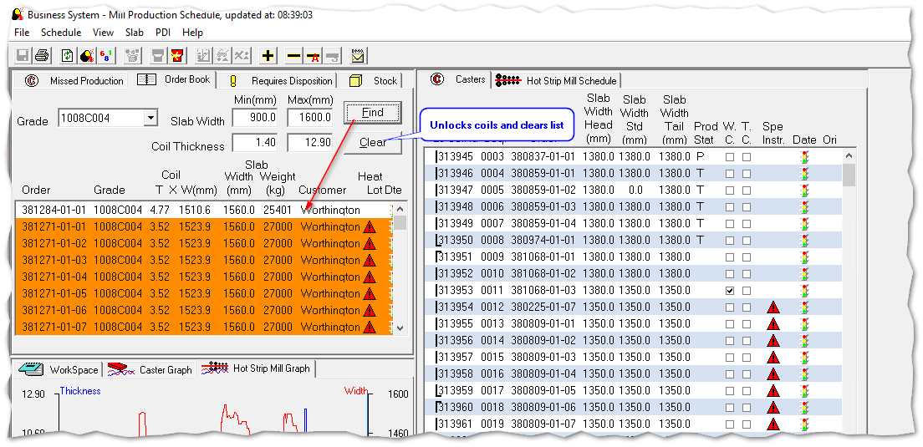

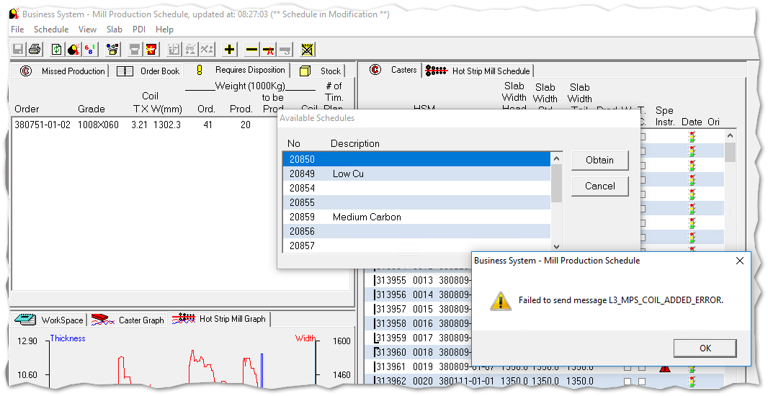

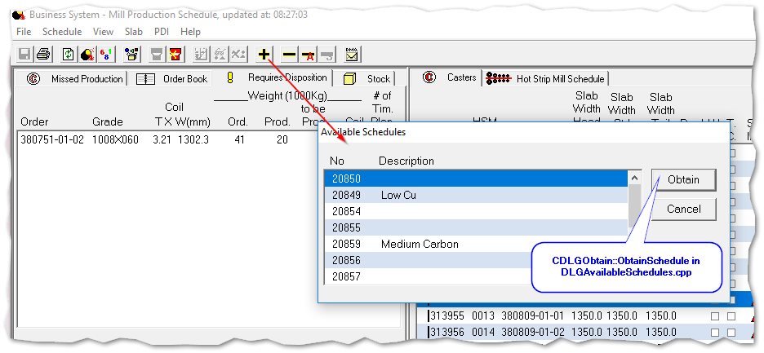

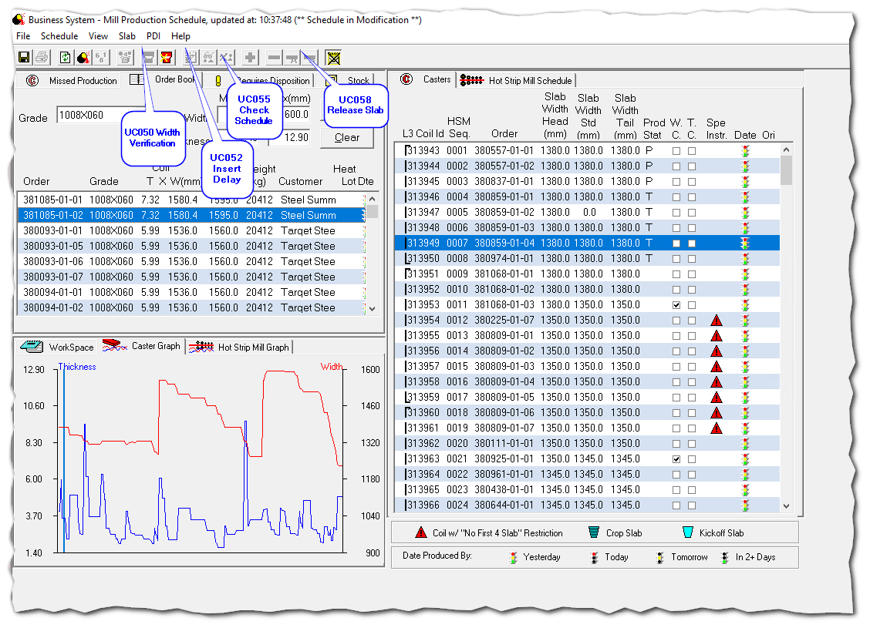

Figure 1- Deprecated Functions

# Questions

Transition Slab ?? (Not Used)

Duplicate Alternate grade toolbar buttons

Add/Remove Pieces to Schedule

Note: Prompt to save changes; E.g. coils are unlocked

# Use Cases - MPS

5 UC033 – Mill Production Scheduling - Display Available Schedules 12

6 UC034 – Mill Production Scheduling - Display Available Schedules Detail 15

7 UC035 – Mill Production Scheduling - Obtain Schedule 19

8 UC036 – Mill Production Scheduling - Display Missed Production 28

9 UC037 – Mill Production Scheduling - Display Order Book 31

10 UC038 – Mill Production Scheduling - Display Requires Disposition 35

11 UC039 – Mill Production Scheduling - Display Stock 39

12 UC040 – Mill Production Scheduling - Display Casters 42

13 UC041 – Mill Production Scheduling - Display Hot Strip Mill Schedule 47

14 UC042 - Mill Production Scheduling - Display Caster Graph 52

15 UC043 - Mill Production Scheduling - Display Hot Strip Mill Graph 54

16 UC044 - Mill Production Scheduling - Display Workspace 56

17 UC045 - Mill Production Scheduling – Save 58

18 UC046 - Mill Production Scheduling - Print 63

19 UC047 - Mill Production Scheduling - Refresh 66

20 UC048 - Mill Production Scheduling - Heat List 68

21 UC049 - Mill Production Scheduling - PDI U033pdate / Retransmit PDI 72

22 UC050 - Mill Production Scheduling - Width Verification – Not Used 74

23 UC051 - Mill Production Scheduling -Transition Slab – Not Used 75

24 UC052 - Mill Production Scheduling -Delays – Not Used 76

25 UC053 - Mill Production Scheduling – Display Alternate Grade 77

26 UC054 - Mill Production Scheduling - Select Alternate Grade 79

27 UC055 - Mill Production Scheduling - Check Schedule – Not Used 83

28 UC056 - Mill Production Scheduling - Release Schedule 84

29 UC057 - Mill Production Scheduling - AutoRelease Schedule 89

30 UC058 - Mill Production Scheduling - Release Slab – Not Used 91

31 UC059 - Mill Production Scheduling - Suspend Interfaces 92

32 UC060 - Mill Production Scheduling - Add/ Remove pieces to Schedule – Not Used 94

33 UC061 - Mill Production Scheduling - Display Piece Detail 95

# Use Cases – Slab Re-Application

34 UC062 – Slab Re-Application – Display Slabs in the Tunnel Furnace 104

35 UC063 – Slab Re-Application – Display Matching Committed Coils for a Slab 106

36 UC064 – Slab Re-Application – Display Matching Required Disposition Coils for a Slab (Implemented on UC063) 114

37 UC065 – Slab Re-Application – Display Matching Stock Coils for a Slab (Implemented on UC063) 115

38 UC066 – Slab Re-Application – Re-Apply Slab 116

39 UC067 – Slab Re-Application – Change search criteria for matching orders 130

40 UC068 – Slab Re-Application – Display Slab Details 133

41 UC069 – Slab Re-Application – Display Order Details 138

42 UC070 – Slab Re-Application – Retransmit PDI to rolling mill 141

43 UC071 - Slab Re-Application – Undo a slab re-application 143

44 UC072 - Slab Re-Application - Resend Schedule 152

45 UC073 – Coil Rework - Refresh Yard 154

46 UC074 - Coil Rework – Input Mandatory Checks 156

47 UC075 - Coil Rework – Send 159

48 UC076 - Delays – Record Delay (manually) 163

49 UC077 - Delays – Record Delay (automatic) 168

50 UC078 - Delays – Assign a Delay Reason 173

51 UC079 - Delays – Split a Delay Event 176

52 UC080 - Delays – Record Slowdown (automatic) 179

53 UC081 - Delays – Assign a Slowdown Reason 184

54 UC082 - Delays – Split a Slowdown Event 187

55 UC083 – Master Data – Delay Reasons Maintenance 190

56 UC084 – Master Data – Slowdown Reasons Maintenance 194

57 UC085 – Master Data – Areas Maintenance 198

58 UC086 – Master Data – Disciplines Maintenance 201

59 UC087 – Master Data – Equipment Maintenance 205

60 UC088 – Delays – Calculate Crew 208

61 UC089 – Delays – Slowdown and Delay Report 211

62 UC090 – Mill Production Scheduling – Drag and Drop into Casters List 213

63 UC091 – Mill Production Scheduling – Drag and Drop into Missed Production 216

64 UC092 – Mill Production Scheduling – Drag and Drop into Stock 219

65 UC093 – Mill Production Scheduling – Drag and Drop into Required Disposition 222

66 UC094 – Mill Production Scheduling – Drag and Drop into Workspace 225

67 UC095 – Mill Production Scheduling – Drag and Drop into OrderBook 228

# Tracing

## Automatic Parsing

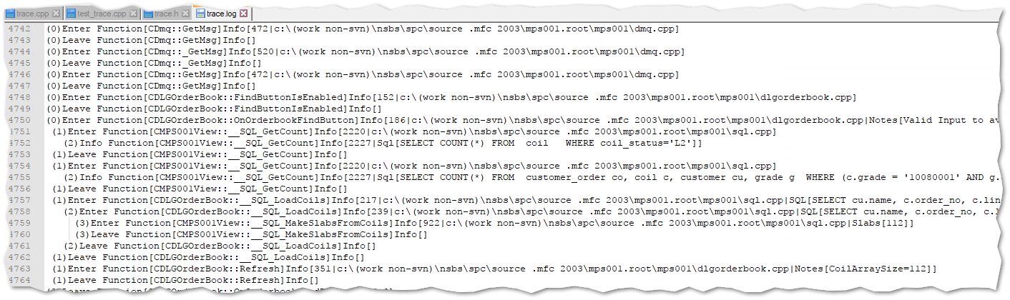

# Order-Book Tab

